Zomato Project

Objective questions

1. The total no. of tables present in the data is 2.

Raw table Country description

1. 25 attributes present in the data.
2. Categorical Columns are 14Continuous Columns are 7

• Restaurant ID • Longitude

• Restaurant Name • Latitude

• Country Code • Price range

• Country • Votes

• City • Average Cost for two

• Address • Rating

• Locality • Date key Opening

• Locality Verbose

• Cuisines

• Currency

• Has Table booking

• has online delivery

• is delivering now

• Switch to order menu

1. Used functions like Remove Duplicates, Find and Replace, TRIM to ensure data accuracy so that becomes usable and suitable to work on.
2. Fill up the countries in the original data using the country code we use vlookup function



1. We make a pivot table to represent the number of restaurants opened in each country by using count if function.



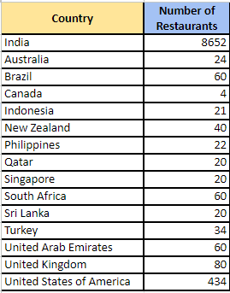

1. We make the pivot table to make the table which shows the number of restaurants opened each year.

Country in rows, Year in columns and in values set as count A which shows the count of restaurant open in each year.

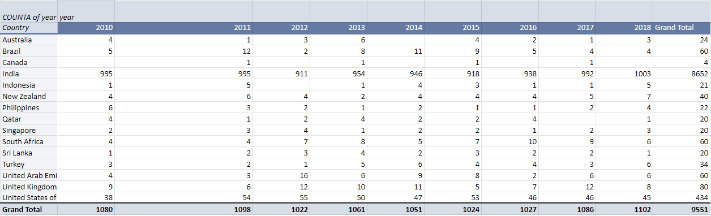

1. We find the total number of restaurants in India in the price range of 4 is by using the count if function.



And the total number of restaurant in India in the price range of 4 is 388.

1. The average number of voters for the restaurants in each country according to the data is find by the average if function.



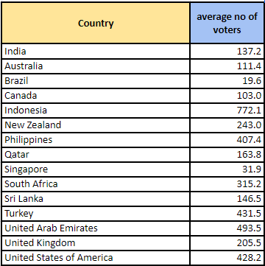

1. To calculate the average rating for all the restaurants that have price range < 4 and provide online delivery by using the “IF” function, Logical Operators, and Aggregation functions



Using this formula we make a column as filtered data and apply the average function on the filtered data column.



Which shows the average rating of 3.3.

1. To highlight the rows of restaurants located in the suggested countries or cities using Conditional Formatting in Google sheet we select the range of all data and go to the conditional formatting after go to the conditional formatting we click on the custom formula.

=or ($D2="Indonesia", $D2="Qatar", $D2="Singapore", $D2="Sri Lanka", $E2="Jakarta", $E2="Tangerang", $E2="Doha", $E2="Singapore", $E2="Colombo")

Through this formula we highlighted the rows of restaurants.

1. Create a new customized price column in the raw data firstly we have to separate the currency symbol form the column name currency. To separate the symbol we use this formula to the other column name as symbol from currency.



After using this formula we have to concatenate the value of the column symbol from currency and the column value of two by using the **concatenate** function in the column name as customised price.



1. To create an array formula in Excel or Google Sheets to count the number of restaurants listed that do not offer online delivery, are in the lowest price range, and have an average cost for two people less than or equal to 250 Indian Rupees we use count if formula with array function.

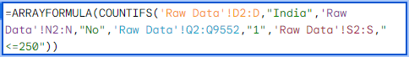

So there are 1685 number of restaurant.

Subjective question

1. A few countries where the team can open newer restaurants with lesser competition are Australia, Canada , Indonesia, Qatar, Singapore, Sri Lanka.

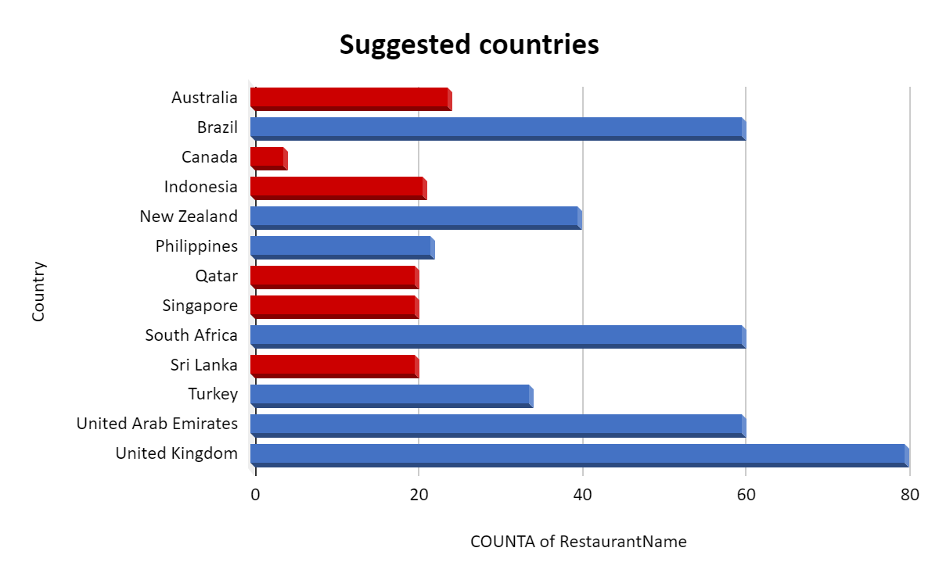

We choose the countries on the basis of count of the restaurant. As the number of restaurant is less the number of competition is also less. So firstly me make a pivot table and in rows we fill the countries and in values we fill number if restaurant and analyse the number of restaurant. We choose those country whose count of restaurant is less and average rating of the restaurant is les then 4.5. The motive of choosing the rating is that the average rating of the country is high it means that the most of the customer is satisfied with the restaurant service.

To briefly analysis the pivot table me make a bar chart to analyse the count of restaurant in each country. We removed the India and United State OF America because they have the highest number of restaurant and make hard to analyse the less count of restaurant.

After making the bar graph we highlight those bar of countries which we selected.

1. The names of States and cities in the suggested countries suitable for opening restaurants are Armidale, Balingup, Dicky Beach, Flaxton, Forrest, Hepburn Springs, Inverloch, Lakes Entrance, Lorn, Macedon, Mayfield, Middleton Beach, Montville, Paynesville, Penola, Phillip Island, Victor Harbor, Chatham-Kent, Consort, Yorkton, Bogor, Jakarta, Tangerang, Doha, Singapore, Colombo.

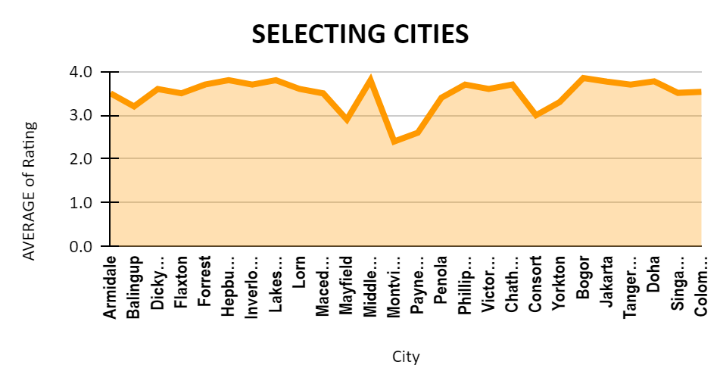

We select the cities or state on the basis of the rating higher the rating of the city restaurant means customer is fully satisfied with the restaurant which makes the high competition and less chance to growth.

To make this pivot table we select our chosen countries in row and states or cities in column, rating of restaurant in values and set it as average and again select the rating in filter section and select those rating whose rating is less then 4.

To analyse the pivot table we make the line chart which show the average rating of the selected cities is < 4.

1. Countries we suggested the current quality regarding ratings for restaurants that are open there is.

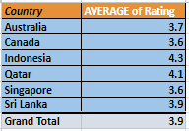

To make this pivot table we selected the countries in the row, rating into values and set it as average and again select countries in the filter section and select the our suggestion countries which show only those countries which we selected.

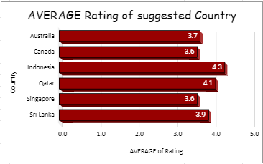

Now to analyse the pivot table we make a bar graph which show the average rating of the suggested countries and name the chart as Average Rating of suggested country.

Through graph we analyse that

* Indonesia has the highest average rating of 4.3, indicating excellent quality.
* Qatar follows with an average rating of 4.1, also indicating high quality.
* Sri Lanka has a good average rating of 3.9, suggesting strong customer satisfaction.
* Australia has a rating of 3.7, indicating good quality but with room for improvement.
* Canada and Singapore both have ratings of 3.6, indicating decent but not outstanding quality.

1. To calculate the current expenditure on food in the suggested countries firstly we have to convert all the currency into one currency and we converted all the currencies into Indian rupees.

To convert the currencies we make a column name is as price in INR and apply the filter on the sheet and choose the currency according to their symbol and multiply the average cost of two according to their currency rate and fill these values on the column price in INR.

Now to calculate the average price expenditure we make the pivot table and fill the countries into row and price in INR in values set as average again put the countries in the filter section and select the suggested countries which show the countries we suggested.

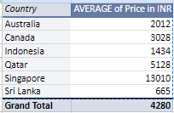

And to analysis the pivot table we make the column chart table.

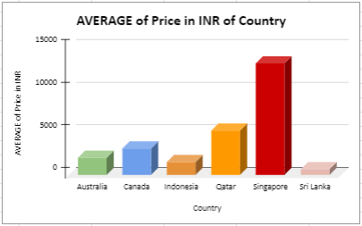

### 1. **Australia (Average Price: INR 2012)**

* **Analysis:** The average price for a meal in Australia is moderate compared to the other countries on the list.
* **Implication:** This suggests a balanced market where consumers are willing to spend a reasonable amount on dining. A new restaurant could compete by offering unique cuisine or dining experiences to attract a steady flow of customers.

### 2. **Canada (Average Price: INR 3028)**

* **Analysis:** Canada has a relatively high average price for meals.
* **Implication:** This indicates a higher cost of living and potentially higher disposable income among consumers. Opening a restaurant here could be profitable if it caters to the preferences of middle to upper-class diners, offering quality food and ambiance.

### 3. **Indonesia (Average Price: INR 1434)**

* **Analysis:** Indonesia has one of the lower average prices for meals.
* **Implication:** The lower cost implies a competitive market with potentially lower profit margins. However, it also means lower operational costs. A restaurant focusing on local flavors or affordable international cuisine might do well.

### 4. **Qatar (Average Price: INR 5128)**

* **Analysis:** Qatar has a very high average price for meals.
* **Implication:** This suggests a luxury market where consumers are used to high-end dining experiences. Opening a restaurant here could be very lucrative if it offers premium services and gourmet cuisine to meet the expectations of affluent customers.

### 5. **Singapore (Average Price: INR 13010)**

* **Analysis:** Singapore has the highest average price for meals on the list.
* **Implication:** The market here is geared towards high-end dining and luxury food experiences. Restaurants can charge a premium if they offer exceptional food quality, service, and unique dining concepts. The high spending indicates a strong potential for profit.

### 6. **Sri Lanka (Average Price: INR 665)**

* **Analysis:** Sri Lanka has the lowest average price for meals.
* **Implication:** The low cost suggests a highly competitive and price-sensitive market. A new restaurant could succeed by focusing on cost-effective operations and appealing to a broad customer base with affordable pricing.

### Overall Expenditure Implications:

* **Higher Average Prices (Qatar, Singapore):** Indicate luxury markets where customers expect and are willing to pay for high-quality dining experiences. This offers high profit margins but requires substantial initial investment and high operating standards.
* **Moderate Average Prices (Australia, Canada):** Reflect balanced markets with potential for steady growth and profitability. Success here depends on quality, service, and innovation.
* **Lower Average Prices (Indonesia, Sri Lanka):** Suggest more price-sensitive markets with lower operational costs. Profit margins might be thinner, but there is potential for high volume if the right niche is targeted.

1. The restaurants from the recommended states that are our biggest competitors are those who has high rating in the suggested cities higher the rating makes the completion high and shows the customer are satisfied with the restaurant

To find the restaurant name we make the pivot table and fill the countries and the cities in the row section and average rating and price in the value section set as the average and again set the ratings into filter section and select the highest rating 3 – 3.9 in the suggested countries

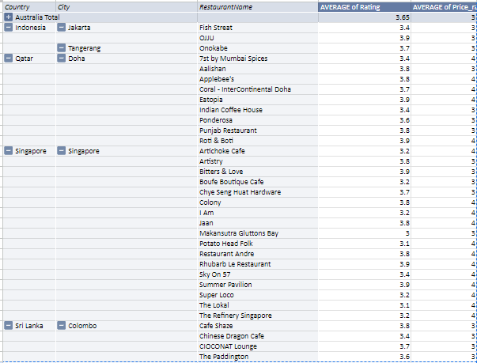

To briefly analyse the pivot table we make the line chart which show the rating of our suggested competitors’ restaurant in the selected cities.

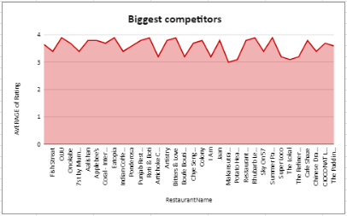

1. To find cuisines should we focus on in the newer restaurants to get better feedback we make the pivot table and select the suggested countries in the table and fill the cuisines in the column and rating in the value section set as average now the pivot table shows all the cuisines of our suggested countries with their average rating.

Now again make the pivot table from the previous pivot table and fill the cuisines in the row section and rating in the value section again fill the rating into filter section and select the highest rating which is above then the 4.1 rating and price range in the value section set it as average.

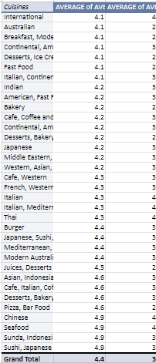

Now we have our cuisines we focus on in the newer restaurants to get better feedback.  
There is a line chat to show the rating of the cuisines.

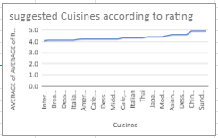

Yes, the choice of cuisines can affect restaurant ratings. Different cuisines appeal to different tastes, and the popularity and quality of a particular cuisine in a specific location can influence how customers perceive a restaurant.

1. According to our current data, we should go for online delivery and table booking to analyse this condition we make the pivot table of row data and select online delivery in the column and has table booking in the column it shows the data that have online table booking on those restaurant who has no online delivery and those who have online delivery and set average rating on vales

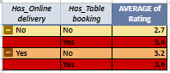

This table clearly show that the average rating of the restaurant is high who has online and has online table booking.

To analyse the table we insert the bar graph according to this table.

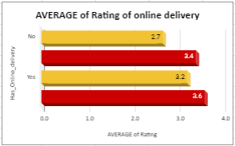

Yes, that affect the customer’s ratings

Second bar which is in the red colour depict the online table booking of those restaurant who doesn’t provide the online delivery and the fourth bar in the red colour shows the online table of those restaurant who has provide the online delivery and both the bars has the highest rating.

So if we go to the on line delivery and has the online table booking it will definitely increase our rating.

1. No, the team shouldn’t keep the rate of cuisines because some cuisines have price range of 2 - 3 and they have the rating above 4. If we increase the price and other restaurant will give the lesser price then it will affect our feedback.

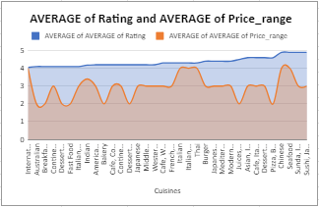

This line chart shows the average rating and average price range of our selected cuisines.

Yes, according to our data are the rates of cuisines and ratings, correlated as shown in the table



Price range of 1 – 2 have less the average rating 2.7 then the price range of 4 – 5 have higher rating 3.7 which shows the cuisines have higher price have higher rating.

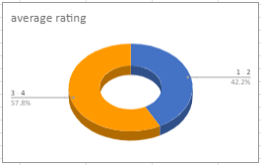

This pie chart shows the rating percentage of the 1-2 price range and 3-4 price range.

1. To find the distribution of the number of restaurants of different price ranges in all the countries we make a pivot table in which countries is in rows and price range is in columns and name of the restaurant is in values as set as count a which shows the number of the restaurant.

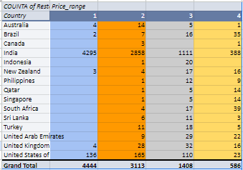

• **India** has the highest number of restaurants in Price Range 1 and 2.

• The **United States of America** has significant numbers across all price ranges, particularly in Price Ranges 2 and 3.

• **Brazil** has a notable count in Price Range 4.

• Other countries like **South Africa, United Kingdom, United Arab Emirates,** and **Turkey** also show diverse distributions across different price ranges.